STUDENTS PERFOMANCE ANALYTICAL REPORT

Introduction

Purpose and Scope

This report analyzes key factors influencing student academic performance using GPA as the primary performance indicator. The study focuses on the impact of absenteeism, tutoring support, and parental education level.

Background

Academic performance is influenced by multiple academic and social factors. Understanding these factors helps schools identify areas requiring intervention and improvement.

Importance

Identifying the strongest predictors of poor performance allows institutions to implement targeted strategies that improve student outcomes and reduce academic failure.

Objectives

Main Goal

To determine the factors that significantly influence student GPA.

Specific Objectives
• To examine the relationship between absences and GPA.
• To identify the number of absences at which academic performance significantly declines
• To evaluate whether tutoring improves academic performance.
• To assess the impact of parental education level on GPA.
• To identify patterns among low-performing students.

Data Source

Description

The dataset consists of 2,392 student records containing GPA, number of absences, tutoring status, and parental education level, study time weekly, ethnicity, age.

Structure

The dataset includes both categorical variables (Tutoring, Ethnicity, Age, Grade, Parental Education, Absence Groups) and numerical variables (GPA).

Limitations
• Causation cannot be confirmed, only relationships are observed.

Data Cleaning

Process
• Checked for missing or inconsistent values.
• Ensured GPA was formatted as a numeric variable.
• Grouped absences into ranges (0–4, 5–9, etc.) for better analysis.
• Using demographic details provided, the numeric codes were replaced to descriptive categories.

Transformations
• Pivot tables were used to calculate average GPA and student counts.
• Absence categories were structured to identify performance trends.

Analysis

Methods

Pivot tables were used to compute average GPA across absences, tutoring status, and parental education levels.

Key Metrics
• Average GPA
• Count of students
• GPA comparison across categories.

Key Findings
• Absenteeism has the strongest negative impact on GPA, with performance decreasing as absences increase.
• Students who received tutoring achieved higher average GPAs than those who did not, showing a positive effect of academic support.
• Among low performing students, the numbers of students who did not receive tutoring is higher than those who did.
• Parental education level showed minimal variation in GPA across categories.
• Overall, attendance and tutoring are the most influential factors affecting student performance in this dataset.

Absences and GPA

This chart shows a strong negative relationship was observed between absences and academic performance.
Students with 0–4 absences recorded the highest average GPA (3.2), while those with 25–29 absences recorded the lowest (0.7).
Academic performance significantly declines after 15 absences.

Tutoring Impact

This chart shows students receiving tutoring had a higher average GPA (2.1) compared to those who did not (1.8).
This suggests that academic support positively influences performance.

Tutoring and Low Performance
This chart shows that among students classified as low performing (GPA < 1.90), a significant proportion are not receiving tutoring support.

Parental Education

This chart shows that students whose parents have High School education have the highest average GPA, while students whose parents have a bachelors or higher degree have slightly lower average GPAs.
This indicates parental education may not be a strong direct predictor in this dataset. The difference are small (all GPAs are around 1.8-1.9), so the impact is not very large.

. The above charts shows the comparison of GPA across absences, tutoring status, and parental education levels.

VISUALIZATION
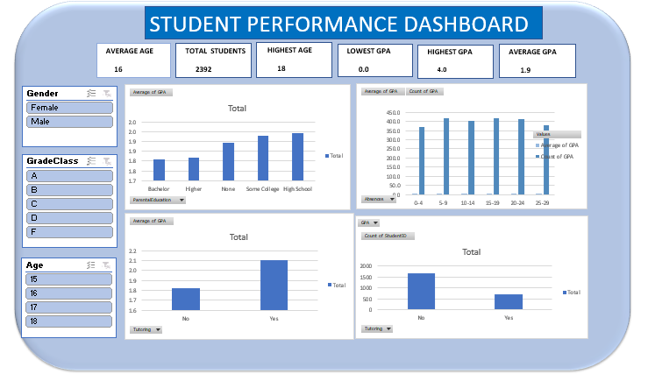

Recommendations

Actionable Steps
• Implement stricter attendance monitoring policies.
• Expand tutoring programs to support struggling students.
• Identify students with increasing absences for early intervention.
• Students with excellent grades should be rewarded to encourage other students.
• Provide academic counselling for the students.
• Flags students once absences reach 0-5 days

Expected Impact
• Improved overall GPA performance.
• Reduction in low-performing students.
• Stronger academic support systems.

Conclusion

The analysis shows that absenteeism has the strongest negative impact on academic performance, while tutoring has a positive influence on GPA. Parental education level appears to have limited direct effect within the students performance.

Improving attendance and expanding academic support programs are critical steps toward enhancing student performance outcomes.

